Innovative Research at the Core of Europe: Inspiring First Annual R&I Days event at the European Commission on 24-26 September

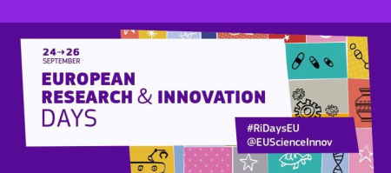

26 September 2019

The European Research & Innovation Days, which took place from the 24th to the 26th of September at the Kanal Centre Pompidou in Brussels, was the first edition of an annual policy event organised by the European Commission, bringing together stakeholders and citizens to discuss and direct the future outlook of research and innovation to ensure a sustainable future for European and global citizens.

The event comprised a three-day policy conference, which was opened on 24 September by Commissioner for Research Carlos Moedas and Director General Jean-Eric Paquet. Both speakers touched on key topics such as the need to be inclusive across Europe to achieve the best results; the need for truly disruptive science in order to make a big impact; and the importance of communicating the achievements of the European research community to the general public and the wider world.

The R&I Days also included a networking space for innovators, researchers, investors and entrepreneurs (‘Innovative Europe Hub’), and the ‘Horizon Village’, where citizens were invited to share their thoughts to shape the priorities of the Horizon Europe research programme.

The ‘Science is Wonderful!’ exhibition also took place to showcase and celebrate the very best EU research and innovation has to offer. It attracted school groups, education professionals, conference delegates, and the general public.

Clean Sky’s Executive Director Axel Krein discussed Clean Sky’s work on smart specialisations with European regions as part of a panel session on Tuesday 24 September. Clean Sky has signed 18 Memoranda of Understanding (MoU) with regions and Member States across Europe, and these MoU have triggered over 35 complementary projects. Read more about the panel session [here](https://www.cleansky.eu/news/european-ri-days-clean-sky-creating-and-leveraging-synergies-across-europe).

The event succeeded in engaging hundreds of citizens and stakeholders, highlighting the important role research and innovation is having in addressing current societal problems.

For more information about the R&I days, please see [here](https://ec.europa.eu/info/research-and-innovation/events/upcoming-events/european-research-and-innovation-days_en)